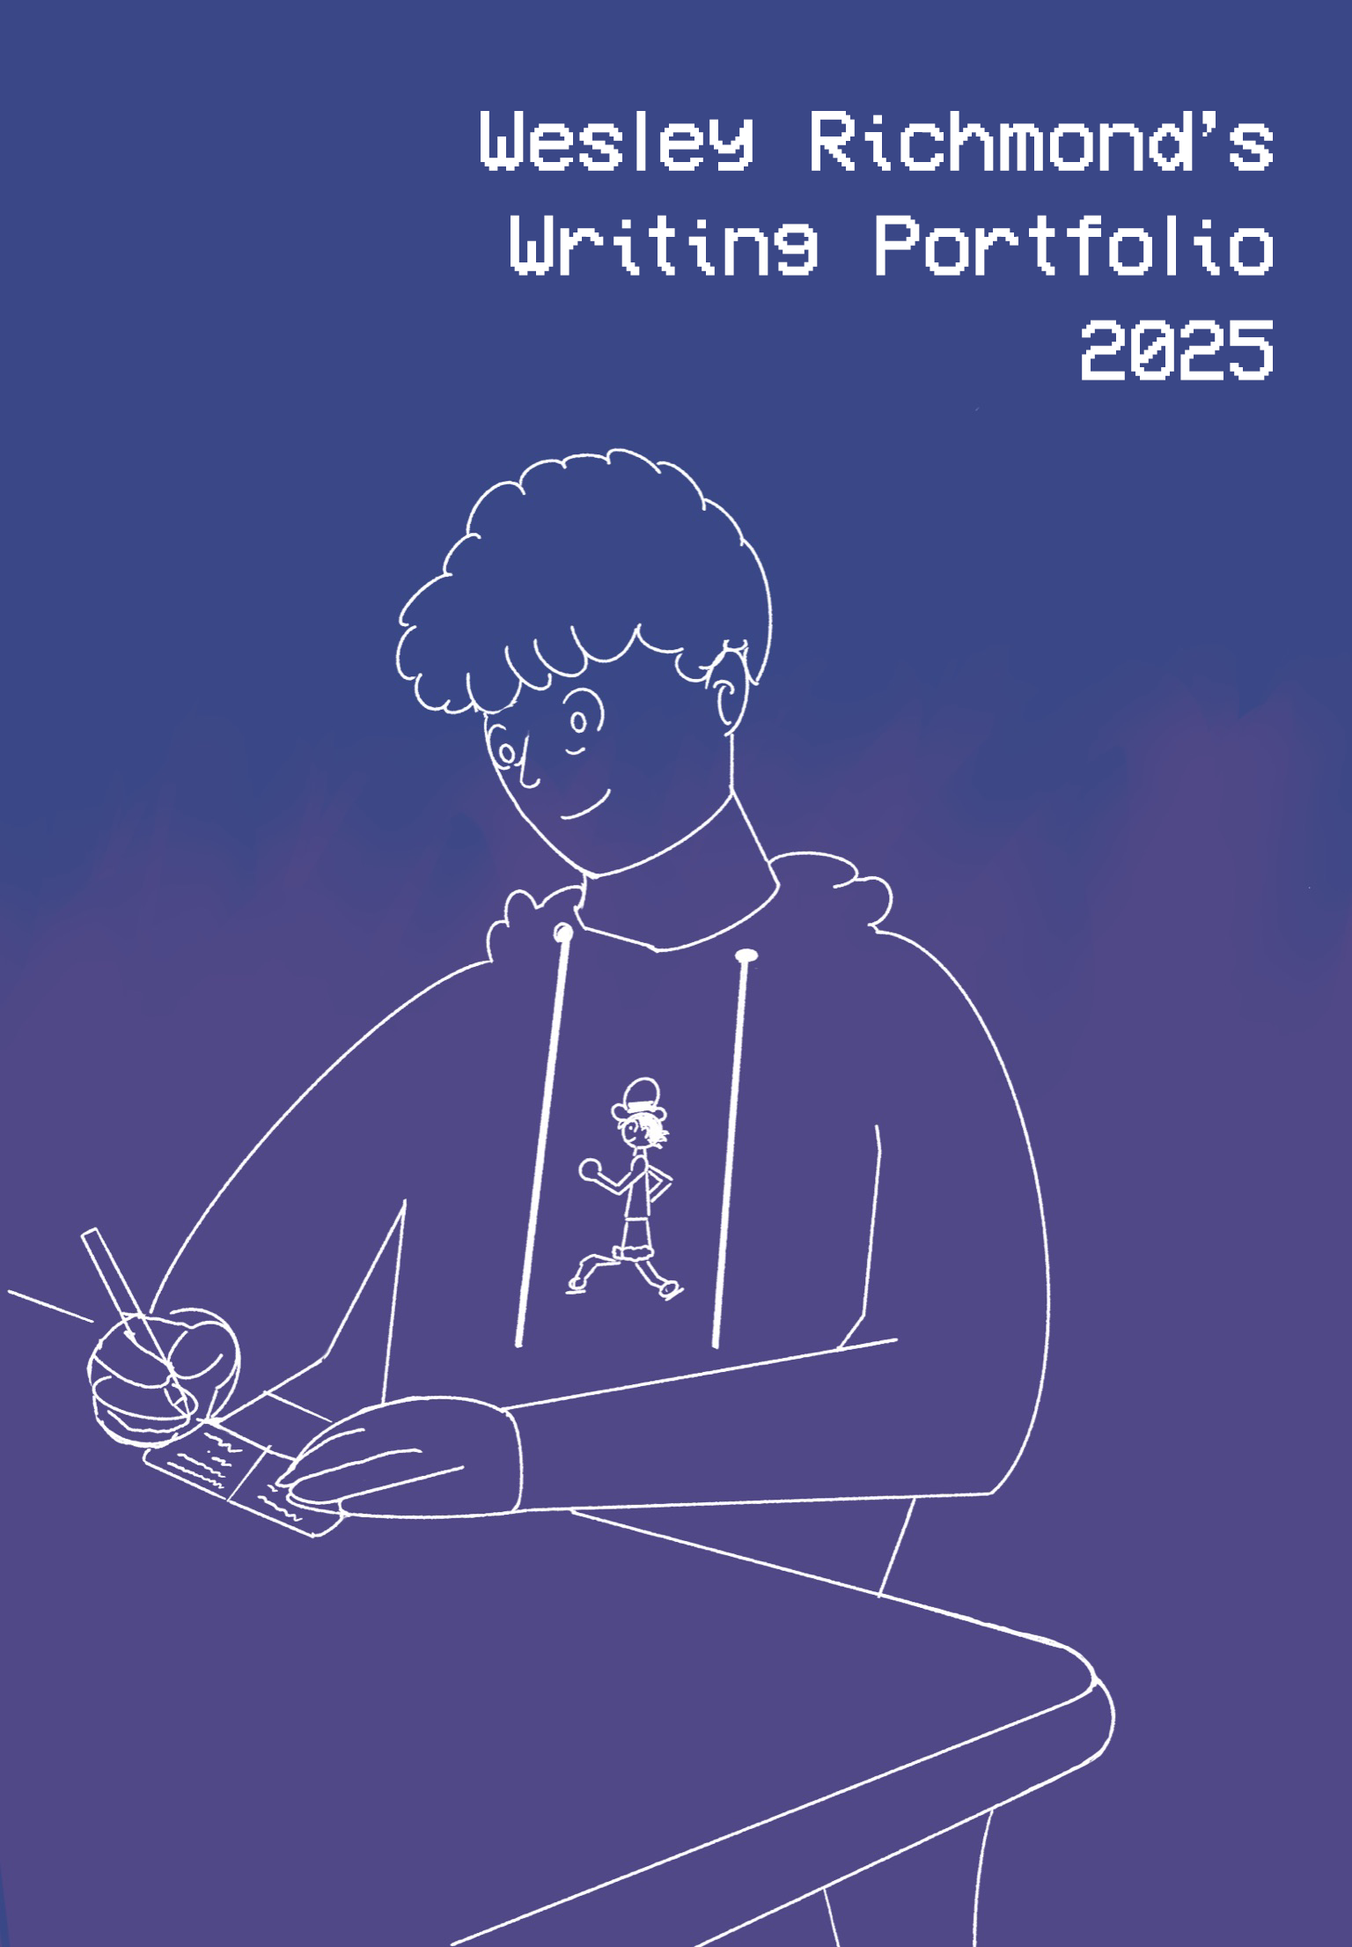

Table of Contents (w/Annotations)
Foreword……………………………………………………………………………………....................3
Academic Writing
Prose Passage Analysis – The Twilight Zone – “The Fear” written by Rod Serling…....................4
A brief analysis of Rod Serling’s prose from The Twilight Zone.
Prose Passage Analysis – “Time and Distance Overcome” written by Eula Biss…….............…...7
An analysis of creative choices in the Eula Biss essay “Time and Distance Overcome.”
Prose Analysis Works Cited……………………….………………………………………..................10
The Podcast Candidate…...……………………….……………………………………….............….11
An independent, undergraduate research paper analyzing podcasts as an advertising and campaigning tool (includes references).
Gothic Troubles...........................................................................................................................26
A research paper examining the adaptations of Night Must Fall and Rebecca (includes references).
Professional Writing
Recognizing the Award Winners(...).............................................................................................38
Blog post for Africa Fire Mission.
The Impact of Leadership Training on County Fire and EMS Services........................................40
Written by Suleiman Adan Issack and edited by Wesley Richmond for Africa Fire Mission. Features additional copy written by me.
Creative Writing
Dracula – A Short Film................................................................................................................ 43
Final script draft, notes, and storyboards for an original short film written and directed by me.
Horror Movie Versus Films...........................................................................................................49
Popular post from my personal blog covering a brief history of and my thoughts on horror crossover films.
Notes on Inclusions and Formatting...............................................................................52
Forward
You can write so much and express so little. But sometimes, you’ll write a sentence that can change a life.
Hi, I’m Wesley! I am a writer, filmmaker, and communications specialist from Cincinnati, Ohio. Thank you for taking time to explore my writing portfolio. This document contains eight pieces of writing from 2025 that illuminate three identities within my work: the academic, the professional, and the creative.
Academically, 2025 presented the most opportunities for growth in my college career. As a Fall 2025 graduate from the University of Cincinnati’s College of Arts and Sciences, I took several challenging courses throughout the year in the fields of Film and Media, Computer Science, Screenwriting, and Communications. My academic writing culminated with my undergraduate seminar research paper where I explore and contrast the adaptations of the critically acclaimed Night Must Fall and Rebecca. Additionally, I expanded my understanding of podcasts, marketing, and campaigning by partnering with graduate students at the University of Cincinnati to publish an undergraduate research paper. Together, these experiences bettered my understanding of screen and digital media in new and exciting ways.
My professional writing skills emerged in new ways in 2025. As the Communications Coordinator at Africa Fire Mission, I honed my skills in professional copywriting and editing. From blog posts to external communications and grant reports, I used my skills to expand the organization’s reach, ultimately expanding its social presence on all platforms by hundreds to thousands of viewers! And, through independent projects with local partners like Cindependent Film Festival and Biggby Coffee Newport, I learned what it takes to create written and video content that truly engages audiences by creating sharable content that helped reach audience goals.
In the midst of these exciting moments, I challenged myself with new personal creative projects. Some of my fondest memories of 2025 came from these projects; writing and directing my own short film that premiered in-person and online in the Winter, chatting with people about topics I wrote about on my blog, and co-hosting a new podcast. These experiences gave me fresh ways to explore my creativity and gain tangible skills in leadership, marketing, and more.
I am so excited to share some snapshots of these moments through my work. I hope you enjoy and maybe even learn something! And I hope to write to you more soon.

Prose Passage Analysis – The Twilight Zone – “The Fear” written by Rod Serling
“Fear, of course, is extremely relative. It depends on who can look down and who must look up. It depends on other vagaries, like the time, the mood, the darkness. But it's been said before, with great validity, that the worst thing there is to fear is fear itself. Tonight's tale of terror and tiny people on the Twilight Zone” (“The Fear”).
“The Fear” is the penultimate episode of the final season of The Twilight Zone’s original run of episodes. It was written by series creator Rod Serling and aired for the first time on May 29th, 1964. This is Serling’s ninety-second episode as a writer for the series and serves as his final writing credit for the entire franchise. The episode follows a police officer named Robert as he checks in on a secluded fashion writer named Charlotte who was talking about seeing strange lights in the sky. After a series of strange events that occur, the duo is confronted by a giant, one-eyed alien. The two panic, and Robert fires at the alien – but it turns out to be a simple trick made with a balloon. The real aliens turn out to be tiny creatures who made the balloon and fly away in a tiny UFO.
At the beginning and end of each Twilight Zone episode, Serling delivers narrations that are typically about a paragraph in length. In his closing narration for “The Fear,” he calls attention to the titular emotion and makes some remarks about it. In his remarks, Serling declares that an aspect of fear’s relativity is “other vagaries,” or abrupt and unexplainable changes and circumstances. Serling uses asyndeton to offer some examples of these vagaries, stating that fear is dependent on “the time, the mood, the darkness” (“The Fear”). Asyndeton is a writing scheme of omission that “names a scheme by which writers omit conjunctions and other connectives between words, phrases, and clauses” (Holcomb et al., 114). Schemes are syntactical elements of sentence structure that can be pointed to and analyzed across the English language as a whole; more specifically, schemes of omission are syntactical elements of sentence structure where words, phrases, or punctuation are deliberately excluded.
Serling’s use asyndeton likely serves two purposes: a practical purpose and a thematic purpose. From a practical standpoint, Serling will often use techniques to shorten his sentences so that his narrations take up less time. The Twilight Zone originally ran from the 1950s to the mid-1960s, and broadcasts in this time had to stick to strict schedules. Especially when he would have to pen these narrations for other writers’ episodes, Serling seemed mindful that his narrations would technically be taking away time from the writers’ stories. As such, his choice to shorten sentences through schemes like asyndeton serves a practical, time-saving purpose.
However, Serling’s narrations were present for a reason; his narrations would help draw the viewers’ attention to certain aspects of the story and help illuminate some of the themes at play. From this perspective, Serling’s asyndeton also serves a thematic purpose and beckons the audience to consider the “vagaries” he speaks of more closely. Serling specifically mentions three elements (time, mood, darkness) that cause the characters fear in the episode. Removing the conjunction and any other words around these elements draws our attention directly to those elements. With this style device, his focus becomes the circumstances that cause fear.
However, Serling isn’t satisfied with just illuminating some of the causes of fear – he wants to argue what kind of fear is worst. The third sentence of his narration features a paraphrased quote. The quote, “the worst thing there is to fear is fear itself,” paraphrases the famous quote from Franklin D. Roosevelt’s 1932 inaugural address, “the only thing we have to fear is fear itself” (“The Fear”). Interestingly, Serling isn’t just quoting this phrase directly. Instead, he changes the framing of fearing fear itself from the “only thing” to the “worst thing.” He also adds a bit more to this paraphrase, stating that this idea has “been said before, with great validity” (“The Fear”). Serling is changing the footing, or the way that writing “is delivered, shared, negotiated between an author and an audience” (Holcomb et al., 61). Instead of just delivering the quote and letting the audience interpret it further, he changes the social footing of his delivery to someone who is an expert in the topic of fear. By stating “with great validity” and using a word with finality like “worst,” Serling uses strong word choice to make himself an expert on fear. The footing is created in such a way that he can’t be wrong, because what he’s saying has been said before and is known to be true: the fear of fear is worse than any other kind of fear. This idea is the central theme of his narration and of the episode. In it, Robert and Charlotte are driven to a state of paranoia by fear and the unknown. This paranoia is ultimately unwarranted, though, as the beings they feared were tiny and fragile all along.
Serling’s writing for “The Fear” and its closing narration came at a time of uncertainty for the United States. This episode aired months after the assassination of JFK and at a time of high tensions between the US and Vietnam. Additionally, there were frequent civil rights protests and demonstrations as this episode was released months before the Civil Rights Act was passed into law. The United States was experiencing change during this period, and there were likely many fearful American citizens. Serling, then, takes the opportunity in his final written episode to address the abstract concept of fear itself. He uses techniques like asyndeton to draw people’s attention to circumstances that can cause fear and ultimately says “that the worst thing there is to fear is fear itself” (“The Fear”). With this footing, Serling’s writing serves to comfort viewers. The Twilight Zone is an iconic and important piece of Americana and was very popular during its original broadcasting. With such a large audience of Americans, Serling takes one of his final opportunities to comfort people and affirm that many things can cause fear, but nothing will be scarier than the idea of fear.

Prose Passage Analysis – “Time and Distance Overcome” written by Eula Biss
Full essay is available to read here.
“Time and Distance Overcome” is an essay written by Eula Biss in March 2009. It is Biss’ first of thirteen essays collected in an award-winning book titled, Notes from No Man’s Land: American Essays. The essay begins with an account of the invention and rise of telephones in the late 1800s, before shifting into an analysis of a series of lynchings using telephone poles across the late 1800s and early 1900s. These lynchings were all committed by white crowds against black men.
Biss effectively uses structure to move between the different parts of her essay. This essay includes three sections, each designated with a short division line: a historical section about the rise of telephones and telephone poles, another historical section about lynchings using telephone poles, and a short section with some personal anecdotes that relate to telephone poles. This choice gives the essay a clear visual distinction between the three main parts.
The structure changes aren’t solely marked by the division lines, though. Biss makes slight changes to the sentence structure throughout the different sections. As an example, Biss has several paragraphs in the first two sections that discuss different locations in the US. In the first section, she writes about two locations like this: “The city council in Sioux Falls, South Dakota ordered policemen to cut down all the telephone poles in town. And the Mayor of Oshkosh, Wisconsin…” (Biss). She writes about more than one place but gives ample context and information about both. In contrast, when writing about several places in the same paragraph in the second section, Biss writes like this: “In 1898, in Lake Comorant, Mississippi, a black man was hanged from a telephone pole. And in Weir City, Kansas. And in Brook Haven, Mississippi. And in Tulsa, where the hanged man was riddled with bullets. In Pittsburg, Kansas…” and later writes, “Riots in Cincinnati, New Orleans, Memphis, New York, Atlanta, Philadelphia, Houston…” (Biss). In these examples, she lists different locations without adding additional context and even cuts out the state names in the second example sentence.
One purpose that the structural choices accomplish is splitting the text into different sections chronologically. Chronologically, this essay covers over one hundred years from the first demonstration of the telephone in 1876 to Biss’ modern perspective in the early 2000s. These chronological distinctions allow Biss to focus on the major events or ideas in each section, without having to write in transitions or move focus away from the main topics.
While the entire essay focuses on several key ideas and central themes that are present in the period of time she writes about, having three major sections also gives the essay a better tonal flow. Showing the section changes visually with a division line gives the reader a moment to pause in between sections with varying tones. Additionally, the use of varying sentence structure in each clearly defined section gives a subtle difference to each section. Building three, well-defined sections is beneficial as Biss writes about topics with varying tones.
The Performing Prose writers simply define tone as “the attitude you display toward the audiences and subject matter of your work” (Holcomb et al, 39). Biss’ essay balances three slightly different tones. For example, the second section of Biss’ essay focuses on atrocities committed using telephone poles. This part is written with a notably darker tone; it contrasts with the (borderline comical) telephone business drama in the first section and the sentimental familial details in the last section.
Biss uses structure to balance these tonal changes because some elements of each section simply don’t work with each other. In the first section, she quotes Mark Twain by writing, “Mark Twain was among the first to own a telephone, but he wasn’t completely taken with it. ‘The human voice carries entirely too far as it is,’ he remarked” (Biss). This quote is framed in a nearly comedic way, as she notes that Twain, a satirist, “wasn’t completely taken with” telephones. His quote reads in a lighthearted way, too. Passages like this work in the first section, as Biss is building context for the second section, which immediately begins with “In 1898, in Lake Comorant, Mississippi, a black man was hanged from a telephone pole” (Biss). The rest of this section features a dark, frank tone as Biss writes about these tragic, horrible realities of the United States’ history. Humorous or light-hearted moments like the Twain quote is at odds with the tone in the second section. Clashing tones may work in some pieces of writing, but in this piece, it could come off as mean-spirited or inauthentic for Biss to clash the tones of these sections directly. It comes off much cleaner and respectful for Biss to separate these tones out, especially with the direct measures she takes.
It is still important to include these three sections in the same essay, though. Including historical context about the rise of telephone poles, the racist crimes committed using telephone poles, and Biss’ musings years after both all work together towards one of her main themes: “Nothing is innocent, my sister reminds me. But nothing, I would like to think, remains repentant” (Biss). It’s very important for these different sections, even with varying tones, to coexist, as clashing emotions and feelings are central to this essay.
Even the chronological structure plays to this, as Biss’ personal memories at the end play in a similar chronological order. “When I was young, I believed that the arc and swoop of telephone wires along the roadways were beautiful,” then “these poles, these wires do not look the same to me,” then “One summer, heavy rains fell in Nebraska and some green telephone poles grew small leafy branches” (Biss). As she was young, she saw beauty in the telephone poles, which was replaced by disdain as her grandfather was injured by one, and she learned about the atrocities committed with them, but she ultimately finishes with an anecdote about a tranquil scene of a telephone pole growing new life. Her callback to the progression of the essay, which is chronologically moving forward but moving tonally from light to dark to light, all work to illustrate her point of how everything can have a dark side, but nothing needs to remain bad forever.

Prose Analysis Works Cited
Biss, Eula. “Time and Distance Overcome.” Notes from No Man’s Land: American Essays, Graywolf Press, February 3, 2009.
Holcomb, Chris, and M Killingsworth. Performing Prose : The Study and Practice of Style in Composition. Carbondale, Southern Illinois University Press, 6 May 2010.
“The Fear.” The Twilight Zone, season 5, episode 35, CBS, May 29, 1964.

The Podcast Candidate: Examining the Utility of Podcasts as a Campaigning Tool

Wesley J Richmond
The Cincinnatus Papers
University of Cincinnati

Abstract
Podcasts are a popular form of media that people use for entertainment and news. As voters in the United States increasingly turn towards alternative forms of media for information, podcasts have filled a key niche in market, demonstrating a capacity to inform voters and sway opinions across various audiences. During the lead-up to the 2024 United States Presidential Election, both Vice President Kamala Harris and President-Elect Donald Trump appeared as guests on podcasts as part of their campaign strategy. This paper uses a research survey to gauge college students’ opinions on this form of campaigning, alongside relevant data from other studies that show the rise in popularity of political podcasts. Research among college students indicates that podcasts can potentially be normalized as a form of campaigning, as audiences search for sources beyond the traditional news media.

Introduction
Americans interact with multiple mediums of communication and media on the internet every day, including videos, blogs, and games. More than other types of content, however, podcasts have retained relevancy since their formal invention in 2005 through a high-level of accessibility across platforms (Bottomley, 2015). Podcasts are audio-only, so audiences can engage with them by simply listening. This allows audiences to enjoy podcasts more flexibly than forms of media that require higher levels of engagement.
Podcasts’ flexibility and high accessibility have allowed for significant audience growth over the years. According to Pew Research Center (2023), monthly podcast listenership has risen from 12% in 2013 to 42% in 2023 (Table 1). As podcast audiences grow, businesses and organizations are increasingly investing in advertisements on popular shows. This shift comes as traditionally reliable methods, such as television ads, are experiencing declining success and viewership. A survey from Civic Science shows that 25% of people actively pay attention to advertisements that are shown on TV (Commisso, 2022). In contrast, another survey indicates that 35% of podcast listeners actively pay attention to ads read on podcasts (Acast Team, 2022).
Table 1 (from Pew Research Center)

As media trends evolve throughout the decades, political campaign strategies have often been forced to stay in tune with viewership rates and audience engagement, responding to changes by adapting their strategies to maximize exposure. Research demonstrates that political ads always increase in volume in the weeks prior to elections, with some television ads re-airing thousands of times during the final stretch (Holman & McLoughlin, 2001). With political groups, lobbyists, and specific candidates willing to spend exorbitant amounts of money, and advertisers looking to diversify their audiences, campaign strategists have begun to branch out to alternative media platforms more than ever (Clark, 2024).
Following these campaign strategies, Kamala Harris and Donald Trump appeared on different podcasts before the 2024 United States Presidential Election as a form of campaigning. This continues a trend set in the 2010s by other major political leaders and takes advantage of the millions of viewers tuning in daily. This relatively new tactic of campaigning sparked discourse from across the political spectrum, as the heightened popularity of podcasts has begun to reshape the news media landscape. This paper contextualizes this discourse and the current political trends existing amongst modern podcast audiences and uses a survey amongst college students to gauge the potential efficacy of podcasts as a campaigning tool.

Literature Review
In today’s so-called podcast renaissance, audiences can choose from over 400 million podcasts designed to appeal to all different types of listeners (Harutyunyan, 2024). Individuals can turn to podcasts for entertainment, news updates, advice, and more. As niche as some podcast topics may be, the growing number of podcasts has cemented their popularity. As a result, some people are beginning to acknowledge podcasts as a reputable form of journalism, and trust among podcast audiences that the information they are hearing is reliable is only slightly below the credibility of major news networks (Whipple et al., 2022). This increase in credibility can be linked to the increase in listeners using podcasts as their primary source of news (Bargielska, 2024).
Currently, the most successful podcast in the United States is The Joe Rogan Experience (Spangler, 2023). The Joe Rogan Experience is a controversial podcast – Joe Rogan has been accused of disseminating false information and popularizing conspiracy theories. He has hosted several controversial conservative and “extremist” figures on his podcast, which increased his visibility and created discourse. Rogan’s relevance in popular culture grew even further in 2024, as Donald Trump and his running mate J. D. Vance chose to appear on his podcast towards the end of the 2024 presidential campaign. Paralleling this, Kamala Harris also chose to appear on widely popular podcasts on the campaign trail, appearing on shows like Alex Cooper’s Call Her Daddy, which is described as “the most listened to podcast by women” (Cooper). Despite the popularity of Cooper’s show, however, recent listenership numbers still show Rogan in the number one spot, while Cooper is in eighth place (Buzzsprout, 2024).

Among the growing number of podcast listeners, demographics indicate that young people are often the target audience for programs and podcasts. In a recent study, 67% of people 18-29 years old stated that they have listened to at least one podcast in 2023, with only 28% saying the same in the 65+ age demographic (Sherer et al., 2023). College students have also identified that one of the reasons they listen to podcasts is for information (Craig et al., 2021). As candidates appear on podcasts and other forms of alternative media, younger audiences are becoming exposed to campaigns that they otherwise may not have tuned in to.

Method
A survey was distributed to college students at the University of Cincinnati with a series of questions regarding the appearance of political candidates on podcasts. The desired audience included students of varying academic disciplines, ages, and gender identities. Students in this survey are mostly pursuing arts, technology, or science majors, with other academic groups rounding out the rest of the results (Table 2).

Table 2

Students identified their grade level (Table 3) and their gender identity (Table 4).
Table 3

Table 4

Students identified their political bias (Table 5).
Table 5

Question topics included the number of podcasts students listen to, the amount of political content they regularly consume, and the impact they perceive podcasts to have on the political landscape. Additionally, students were given the opportunity to give their opinions on both Kamala Harris and Donald Trump’s appearances on podcasts.
Results
The majority of students in this survey listen to podcasts and consume political content at least occasionally (58.3% and 95.8% respectively). Many students note that they use the internet to consume political content. Sources include YouTube, TikTok, Instagram, X, and other social media platforms.
Among the surveyed group, Donald Trump and Kamala Harris’ appearances on podcasts influenced the students in a similar way; students overwhelmingly indicated that their appearances did not impact their political opinions (Tables 6 and 7).
Table 6

Table 7

Donald Trump’s podcast appearances negatively affected opinions slightly more than Kamala Harris’ appearances. Between the two candidates, Trump’s appearances made three students less likely to vote for him, while Harris’ appearances only made two students less likely to vote for her (Tables 8 and 9).
Table 8

Table 9

Overwhelmingly, students agreed that political candidates appearing on podcasts was an effective campaign strategy (Table 10). Only 8.1% of respondents thought that it was not an effective strategy.
Table 10

Students offered additional written thoughts. One student wrote that podcast appearances “…can either encourage or discourage undecided voters based on how the candidate comes off as genuine or fake.” Another student commented, “I would say that simply appearing in a podcast I listen to (if I did listen to podcasts) would not be enough to sway my opinion in one way or another. What could sway me, however, is their talking points in the podcast.”

Discussion
Among this group of students, it is clear that podcasts can be received as part of an effective campaign strategy. While not all students listened to podcasts frequently, students overwhelmingly agreed that podcasts can be used as part of a successful campaign strategy, and the candidates’ podcast appearances did sway some opinions.
Interestingly, this campaigning impacted about the same number of students, with both podcast appearances making two students more likely to vote for the candidates. Conversely, both candidates had students become less likely to vote for them due to their podcast appearances. While this may seem like it detracts from the effectiveness of podcast campaigning, these statistics could be an example of confirmation bias, with listeners allowing the podcasts to reaffirm their positive or negative opinions of the candidates; if a listener already viewed a candidate favorably or unfavorably, it’s possible that the candidate’s appearance on the podcast would reinforce their feelings.
While confirmation bias can relate directly to listeners’ opinions of the candidates, it can also apply to their opinions of the podcast hosts. As mentioned earlier, Donald Trump appeared on The Joe Rogan Experience, a popular, yet controversial, podcast. Since Rogan is a popular figure to some and a controversial figure to others, his presence could be enough to sway people’s opinions alone. Rogan’s controversies could also account for why Trump saw one more person less likely to vote for him than Harris, as the association could be enough to change someone’s mind.
Many students reported that the podcast appearances did not directly impact their political opinions, specifically in regards as to who they were planning to vote for. However, this does not necessarily mean that podcasts are an ineffective campaigning tool. The indifferent responses could indicate that the campaign appearances convert moderate or centrist students more than students with strong pre-established political convictions. Only 5.4% of students identified as politically centrist, and a total of 32.4% of students identified as being completely left-leaning or completely right-leaning. It’s possible that because the students polled had strong convictions, these appearances impacted them less. Campaigning with podcasts potentially changes the opinions of center-leaning voters more than partisan voters.
Additionally, while some students listen to podcasts regularly and listened to these campaign episodes specifically, about 31% of students do not listen to podcasts and about 29% of students listen to podcasts infrequently. It is interesting to note, though, that even students who do not listen to podcasts still agree that podcasts are an effective campaign strategy. Listening or not, these appearances impact voters. Appearances generate additional discussion online and can be used to appeal to new groups of people.
Based on the results of my survey, candidate appearances on podcasts seem to boost their visibility amongst university-age young adults. Candidates appearing on podcasts sway the opinions of some college students and appear to be effective to students who are not swayed in their political convictions. In the future, reviewing more campaign appearances on podcasts will likely help cement podcast appearances’ effects on audiences and voter inclinations. Based on future results, we could see the efficacy of podcasts alter established campaigning trends and potentially see more candidates us these strategies in the future.

References
Acast Team. (2022, June 30). Are you listening? How Acast has quantified the “attention economy” for podcasting. Advertise.acast.com. https://advertise.acast.com/news-and-insights/how-acast-quantified-the-attention-economy-for-podcasting
Bargielska, K. (2024, June 17). Digital News Report: Podcast Listeners are Younger, Wealthier, and More Likely to be Men - AdTonos. AdTonos. https://www.adtonos.com/podcast-listeners-younger-wealthier-and-more-likely-to-be-men-according-to-digital-news-report-data/
Bottomley, A. (2015). Podcasting: A Decade in the Life of a “New” Audio Medium: Introduction. Journal of Radio & Audio Media, 22(2), 164–169. https://doi.org/10.1080/19376529.2015.1082880
Buzzsprout. (2024). Podcast Statistics: Growth and Demographic Data for 2024. Www.buzzsprout.com. https://www.buzzsprout.com/blog/podcast-statistics
Clark, T. (2024, November 7). Why experts say this election showed the power of podcasts | The Current. The Current. https://www.thecurrent.com/political-presidential-election-2024-podcasts
Commisso, D. (2022, September 21). Here’s What Watching TV Looks Like for Americans Today. CivicScience. https://civicscience.com/heres-what-watching-tv-looks-like-for-americans-today/
Cooper, A. (n.d.). Call Her Daddy. Spotify. https://open.spotify.com/show/7bnjJ7Va1nM07Um4Od55dW
Craig, C. M., Brooks, M. E., & Bichard, S. (2021). PODCASTING ON PURPOSE: EXPLORING MOTIVATIONS FOR PODCAST USE AMONG YOUNG ADULTS. International Journal of Listening, 37(1), 1–10. https://doi.org/10.1080/10904018.2021.1913063
Downing, J. D. H. (2001). International Encyclopedia of the Social & Behavioral Sciences. Www.sciencedirect.com. https://www.sciencedirect.com/topics/social-sciences/alternative-media
Harutyunyan, M. (2024). Podcast Statistics: Must-Know Insights and Trends for 2024. Loopexdigital.com. https://www.loopexdigital.com/blog/podcast-statistics
Helmore, E. (2022, January 30). Joe Rogan: rise of a highly controversial cultural power. The Guardian. https://www.theguardian.com/us-news/2022/jan/30/joe-rogan-neil-young-feud-spotify-music-streaming-industry
Holman, C. B., & McLoughlin, L. P. (2001). Buying Time 2000 (pp. 52–59). Brennan Center.
Pew Research Center. (2023, June 15). Trends and Facts on Audio and Podcasts | State of the News Media. Pew Research Center’s Journalism Project. https://www.pewresearch.org/journalism/fact-sheet/audio-and-podcasting/
Shearer, E., Liedke, J., Matsa, K., Lipka, M., & Jurkowitz, M. (2023, April 18). Podcast use among different age groups. Pew Research Center’s Journalism Project. https://www.pewresearch.org/journalism/2023/04/18/podcast-use-among-different-age-groups/
Spangler, T. (2023, November 29). Joe Rogan Again Had Spotify’s No. 1 Podcast in 2023. Will He Reach a New Deal With the Streamer? Variety. https://variety.com/2023/digital/news/spotify-top-podcasts-2023-list-joe-rogan-deal-renewal-1235809680/
Stocking, G., Mitchell, A., Matsa, K. E., Widjaya, R., Jurkowitz, M., Ghosh, S., Smith, A., Naseer, S., & Aubin, C. S. (2022, October 6). 1. Americans are more aware of some alternative social media sites than others, but overall, very few get news there. Pew Research Center’s Journalism Project. https://www.pewresearch.org/journalism/2022/10/06/americans-are-more-aware-of-some-alternative-social-media-sites-than-others-but-overall-very-few-get-news-there/
Whipple, K., Ashe, I., & Cueva Chacón, L. M. (2022). Examining Podcast Listeners’ Perceptions of the Journalistic Functions of Podcasts. Electronic News, 17(1), 193124312211376. https://doi.org/10.1177/19312431221137650

Gothic Troubles: Examining Adaptations of Gothic Tales

Wesley J. Richmond
Film and Media Studies, College of Arts and Sciences, University of Cincinnati
FILM 5001: The American Gothic Film
Dr. Megan Boyd
December 12, 2025

Introduction
Will H. Hays is commonly cited in works on early American cinema due to his controversial Hays Code. This Code, the shorthand for the Motion Picture Production Code, led to the censorship of countless films beginning in the 1930s. Though it may be arbitrary, it can be difficult to fully grasp the extent to which films were censored, unless there is a way to directly compare them to an original draft. Fortunately (and potentially unfortunately for the filmmakers), the 1930s saw the rise of popular genre cycles like the gothic that included numerous adapted features that can be compared to the source material.
Gothic films like Alfred Hitchcock’s Rebecca have received modern adaptation analysis in novels like Hitchcock on the Source or Laura Hubner’s Fairytale and Gothic Horror: Uncanny Transformations in Film. Hubner (2018) writes that “[Rebecca] has been variously classified as ‘female gothic,’ ‘gothic romance,’ ‘thriller’ and an initiator of the ‘Bluebeard’ or ‘persecuted wife’ 1940s Hollywood cycle” (p. 75). The cycle Hubner describes, commonly referred to as the female gothic style, is especially fascinating to consider in relation to the Hays Code, as popular gothic tropes such as suspicion, romance, and murder were all subject to scrutiny by the Code. Other films, like Dick Thorpe’s Night Must Fall, have fallen under the radar in terms of adaptation and gothic studies, despite the apparent “Hitchcockian” elements that relate it to films like Rebecca, as noted by Film Comments 2004’s Opening Shots (p. 8). The elements common to the female gothic cycle are all featured in Night Must Fall, which makes it an interesting film to consider in this analysis. Widely studied or not, though, both contain many similar elements that are of concern under the Hays Code.
As mentioned before, Hays as a figure is commonly cited in film studies because of his Code, but less frequently for the words he wrote himself. In his memoir, Hays (1955) comments on what he found especially concerning in films, with one subject being “the distinction between realism and romance. We all agreed that as far as possible life should not be presented in such a way as to place in the minds of youth false values of life” (p. 442). Hays concerns himself with ensuring that film does not romanticize values he disagrees with, and as a result, the Code implements a level of censorship that can fundamentally change how audiences read certain films. This paper will examine the adaptations of Rebecca and Night Must Fall. As the filmmakers adapted these critically acclaimed European gothics to American gothic films, they made creative choices that reduced the amount of romantic or violent interactions. Changes like these are indicative of trends in early American gothic films, as they were influenced by external factors such as limitations in the medium of film, challenges from the studio system, and censorship from the Hays Code.
Understanding the Choices in Adaptations
Filmmakers in the 1930s and 1940s in the United States faced several external factors that affected the artistic choices they could make. Most broadly, film, during that time, was still a young medium. As such, auteurs and large studios alike struggled to find the best way to bring a screenplay to life, especially when considering adapted screenplays. Adaptations from media like novels, stage plays, and radio productions caught on quickly and became a cornerstone of film in the 1930s with high-profile releases like Pygmalion and Gone with the Wind. As such, as early as 1937, producers and film analysts had already caught on to the prominence of these productions, with writers like Barrett Kiesling noting in their informative text Talking Pictures: How They Are Made, and How to Appreciate Them, “When the search leads to a successful play, such as the London stage mystery success, Night Must Fall, there are usually no bars… Producers expect to pay a high price for a current stage hit, for it has already proven its ability to attract and to entertain people” (pp. 54-55). Despite the apparent success of adaptations, it was still assumed that there would be changes between the original version and the adapted screenplay. Kiesling (1937) later writes, “[in Night Must Fall], Even the verist tyro in dramatic analysis can see where the alterations necessary for screen form created a more powerful dynamic onrush than that possible for the original stage play” (p. 64). Differences between mediums may be a given, but there are additional constraints at the time that provided challenges to filmmakers.
One of these other concerns were constraints caused by the early studio system. In a piece on Dick Thorpe, director of Night Must Fall, writer Shawn Levy (1993) discusses some of these constraints, including Thorpe’s tricky time and budget constraints, directing “66 films in 30some years” with “None of his Thirties films cost more than $250,000 (blockbusters of that time could cost, in comparison $3 million) – and most were still less pricey” (p. 76). While Thorpe still had resources at his disposal, he certainly faced constraints due to the studio that gave him less time and smaller budgets to adapt critically acclaimed screenplays.
Hitchcock faced similar challenges in adapting Rebecca. In Laura Hubner’s (2018) writing on Rebecca, she notes that the film was “guided by the visions of producer David O. Selznick, who held a keen interest in maintaining fidelity to the original source” (p. 75). R. Palmer and David Boyd examine this guidance in Hitchcock on the Source, and they note that the director faced “endless interfering” while working on Rebecca. Though elements of his style still formed during the production, as Boyd (2011) discusses Hitchcock’s “’cutty’ editing” and “subjective long take,” Hitchcock still faced a level of studio interference at the hands of the producer (p. 124).
Potentially more constraining than these factors was the historical reality of the Hays Code. As previously mentioned, the Hays Code widely impacted films starting in the 1930s. These guidelines limited what filmmakers could show on screen, with specific guidelines limiting depictions of violence and sexuality. These two categories were especially pertinent to gothic filmmakers, as the common romance and murder mystery elements clashed with these rules. A notable rule relating to violence was that “[Crimes against the law] shall never be presented in such a way as to throw sympathy with the crime as against law and justice or to inspire others… the technique of murder must be presented in a way that will not inspire imitation” (“"Complete Nudity Is Never Permitted": The Motion Picture Production Code of 1930”, n.d.). These elements imposed strict limits on the kinds of murder-mystery plot points that could be shown. Additionally, romance had strict guidelines too, including “[scenes of passion] should not be introduced when not essential to the plot. Excessive and lustful kissing, lustful embraces… are not to be shown” (“"Complete Nudity Is Never Permitted": The Motion Picture Production Code of 1930,” n.d.). The vagueness of the Code’s rules made it especially challenging, as it ultimately wasn’t up to the filmmakers as to what constitutes these inappropriate kisses or embraces. While flatly removing these elements may avoid Hays’s concern of romanticizing unfavorable values, these changes combine with the other challenges in early filmmaking to drastically alter how some stories are told.
From difficulties in early filmmaking to the Hays Code and even studio interference, filmmakers faced many challenges in the thirties and forties that limited their creative control when adapting works to the screen. Rebecca and Night Must Fall serve as notable examples of this phenomenon, as both films adapt critically acclaimed works around the popular female gothic cycle. When considering the notable changes in the adaptations of these stories, it is especially important to scrutinize the changes in depictions of romance and violence. Both subjects were specific concerns in the Hays Code and receive frequent mention in contemporary reviews. The romance and violence of these films are central to their progression, yet, as will be described in the following sections, both elements received censorship and changes as they made the jump to cinema.
Challenges in Expressing Romance in Different Mediums
Both versions of these stories center on a turbulent, heterosexual romantic relationship. Rebecca centers on the marriage and relationship between Mrs. de Winter and Maxim de Winter and Night Must Fall features a growing romance between Olivia and Dan. When these stories were adapted to film, filmmakers faced challenges in faithfully adapting these central romances. Some of these challenges relate specifically to the change in media and lead creative, while other challenges are indicative of greater trends in American gothic films as described previously.
A unique aspect of both the book and film versions of Rebecca is that both are told in past-tense; the novel begins with the narrator recounting how her and her husband are reflecting upon their now destroyed home called Manderley, while the film starts with a short narration of the protagonist dreaming of Manderley before leading into the story proper. While both narratives move through the story linearly from here, the novel reads like an extended flashback, while the remaining runtime of the film is free from these conventions. An excellent example of this comes from the end of Rebecca’s second chapter, that reads: “I remember well that plate of ham and tongue. It was dry, unappetizing, cut in a wedge from the outside, but I had not the courage to refuse it… ‘It’s Max de Winter,’ [Mrs. Van Hopper] said, ‘the man who owns Manderley. You’ve heard of it, of course. He looks ill, doesn’t he? They say he can’t get over his wife’s death…’” (Du Maurier, 1938/2006, pp. 10-11). Besides this passage illuminating the novel’s tense, it also points towards another major difference between the novel and the film, that being the presence of Mrs. de Winter’s narration and thoughts that are constant in the novel but generally absent in the film.
Mrs. de Winter’s internal thoughts are important in the discussion of the romance of Rebecca, as her narration offers additional allusions to romance that are not present in the film. For example, during the first morning in Manderley in chapter eight of the novel, Mrs. de Winter only has a brief encounter with Maxim before he leaves. After he departs, Mrs. de Winter thinks how that “was not how I had imagined my first morning; I had seen us walking together, arms linked, to the sea, coming back rather late and tired and happy to a cold lunch, alone, and sitting afterwards under that chestnut tree I could see from the library window” (Du Maurier, 1938/2006, p. 81). This nuanced expression of Mrs. de Winter’s unrealized romantic desire is completely absent in the film, save for a look of disappointment. While even some contemporary films would feature narrations, this adjustment in adaptation is more notable when considered in tandem with the change in some spoken lines. Take, for example, Maxim’s dialogue on page forty, where he bluntly states his romantic desire for the protagonist: “I ask you to come with me because I want you and your company” (Du Maurier, 1938/2006, p. 40). The film, instead, has Maxim say a more indirect line of “I ask you to come with me because I want your company” (Hitchcock, 1940).
Scholars and contemporary reviewers often praised the script’s faithfulness to the book, though some writers like scholar Donald Ranvaud note how impactful the seemingly small changes can be. In reference to Maxim’s words of romantic interest, Ranvaud (1980) writes, “Interestingly enough, the film, which on Selznick's peremptory order follows the book very closely indeed, contains a substantial if very small omission at this point.” Despite a change like this only removing a few words, they can dramatically change how characters and their desires are read. This is especially interesting to consider in relation to the Code’s insistence on removing any possibility of romanticizing violence. Maxim’s violence will be explored more in the following section, but it’s important to consider that some changes in how Maxim is presented make him traditionally less desirable, which fits with the contemporary ideal of not romanticizing figures of crime or violence.
Rebecca indicates a straightforward dimming of romantic or sexual desires when adapting a gothic story to an American gothic film; however, Night Must Fall’s adaptation complicates this understanding. After all, the film ends with a passionate embrace between Olivia and the central family’s attorney, Justin, where she states, “It’s more than my life you saved tonight, it’s my reason” (Thorpe, 1937). There are also moments of romantic interest between Olivia and Dan, who’s revealed to be the film’s central murderer. When compared to the original stage play, though, the differences in adaptation become clear. For example, the brief exchange between Olivia and Justin in the film is instead a moment where Dan kisses Olivia and then she breaks down crying. In the stage play, Olivia passionately attempts to defend Dan by offering “It's all right. You won't die. I'll tell them I made you do it. I'll tell lies…” (Williams, 1935/2005). Rather than a straightforward removal of romantic or sexual interest and encounters, the film Night Must Fall reduces the moments between Olivia and Dan specifically. This fits in with the constraints of the Hays Code. As mentioned before, filmmakers could not portray violence (especially murders) in a way that would make it appealing. Moving some of the physicality from Olivia and Dan to Olivia and Justin is a clever way to remove some desirability from Dan, as he is no longer the source or focus of physical romance. This also aligns with the changes to Maxim’s character.
Violence in Gothic Adaptations
In contrast to the changes in the presentation of romance, both Rebecca and Night Must Fall feature a number of straightforward reductions in violence. Both stories feature important moments where acts of violence are central to their conflicts, but both film adaptations change these climactic moments.
Rebecca’s violence generally follows conventions like those written about in academic Michelle A. Massé’s (1990) Gothic Repetition: Husbands, Horrors, and Things That Go Bump in the Night; Maxim fits in with the idea that “the master of the house, apparently the source of evil, is revealed to be more sinned against than sinning” (p. 679). In adapting this evil, Rebecca’s climactic ending specifically featured a drastic alteration. In the novel, it is revealed that Maxim shot and killed his first wife Rebecca, whereas the film skirts an exact explanation, with the cause of death ultimately coming from an accident as Rebecca falls and hits her head during their argument. Whether it was cut due to the Hays Code or the studio, this moment intrinsically changes how the audience reads Maxim as a character.
Night Must Fall was altered in similar ways. The stage play features several references to graphic imagery. Most notably, the play features a chilling scene where Dora dashes into the house from the family garden and exclaims “A hand ... Somebody's hand!... Oh, Miss Grayne ... somebody's hand....” (Williams, 1935/2005). The allusion to a severed hand is completely removed in the film’s story. While Night Must Fall featured several censored moments like this, the film was still described by contemporary reviews as having a “macabre nature” and being the “most startling departure from commonplace characterization and story” from films at the time, despite featuring essentially no on-screen violence (Collier, 1937; Stromberg, 1937). Despite how central the violence is to the narrative, the film features fewer allusions to the grisly acts of Dan throughout its runtime than the original play.
Compared to the changes in romance, both Rebecca and Night Must Fall feature a universal decrease in references to violence. Even though the murder mystery and violence are common points of discussion in contemporary reviews, the violence is clearly less prevalent. Interestingly, both stories were still remarked upon by reviewers in the 30s and 40s respectively as being shocking, with reviewers describing Night Must Fall as having a “macabre nature” and being a “startling departure from common place characterization and story” (Collier, 1937; Stromberg 1937). Despite this, both films are notably less shocking. Considering the Hays Code’s insistence to avoid romanticizing violence in early Hollywood films, it follows that filmmakers were consistent in removing instances of violence.
Conclusion
Early American gothic filmmakers faced a variety of challenges in straightforwardly adapting European gothic tales. Taking Night Must Fall, a 1937 film that shortly precedes the common female gothic film cycle but features many overlaps, and Rebecca, a commonly cited film in this cycle, as examples, it’s clear that filmmakers adjusted their adaptations of popular European gothic tales to alter instances of romance or violence. The mysterious relationships between Olivia and Dan and Mrs. de Winter and Maxim are ultimately presented in new ways, usurping the general consideration of who these characters are.
Hays (1955) wrote in the forward of his memoir that “Perhaps the greatest lesson I have learned is that it is possible to change public opinion, to marshal it behind constructive projects like woman suffrage or clean movies. Two indispensable factors are a sound plan and a vigorous organization for winning the co-operation of rightthinking men and women” (p. V). His Code, the pressures of studios, and growing pains of the new medium of film in some ways succeeded in changing the public’s opinion. Despite the censorship in Night Must Fall and Rebecca, reviewers still considered films like these “macabre” (Collier, 1937). In addition to shocking audiences despite the reductions in romance in violence, conversations around the stories of Night Must Fall and Rebecca often center on the films discussed in this paper, rather than their original versions. The challenges in adapting these films cemented very particular images of these stories in the public consciousness. It’s interesting to consider what conversations around these films and gothics broadly would be like if the adaptations were more accurate. These films permeate culture as they are, though, and the historical consequences of these adaptations may be a field of future studies.

References
Boyd, D., Ebrary, I., & Palmer, R. (2011). Hitchcock at the Source: The Auteur as Adaptor. Suny Press.
Collier, L. (1937). Reviews - Night Must Fall. Picturegoer, Jul-Dec 1937, 32. Media History Digital Library.
“Complete Nudity Is Never Permitted”: The Motion Picture Production Code of 1930. (n.d.). George Mason University. https://historymatters.gmu.edu/d/5099/
Du Maurier, D. (2006). Rebecca. Harper. (Original work published 1938)
Hays, W. H. (1955). The Memoirs of Will H. Hays. Doubleday & Company, Inc.
Hitchcock, A. (Director). (1940, March 21). Rebecca. United Artists.
Hubner, L. (2018). Rebecca Returns: Death and Renewal Beyond the Door. Palgrave Macmillan UK EBooks, 75–115. https://doi.org/10.1057/978-1-137-39347-0_4
Kiesling, B. C. (1937). Talking Pictures: How They Are Made, How to Appreciate Them. Johnson Publishing Company.
Levy, S. (1993). Dick Thorpe: All-American. Film Comment, 29(1), 76–81. JSTOR. https://doi.org/10.2307/43406167
Massé, M. A. (1990). Gothic Repetition: Husbands, Horrors, and Things That Go Bump in the Night. Signs: Journal of Women in Culture and Society, 15(4), 679–709. https://doi.org/10.1086/494624
Opening Shots. (2004). Film Comment, 40(3), 6–8. JSTOR. https://doi.org/10.2307/43456700
Ranvaud, D. (1980). Rebecca. Framework: The Journal of Cinema and Media, 13(13), 19–24. https://www.jstor.org/stable/44109677
Stromberg, H. (1937). Flash from Hollywood on “Night Must Fall.” The Film Daily, Apr-Jun 1937. Media History Digital Library.
Thorpe, R. (Director). (1937, April 30). Night Must Fall. Loew’s Inc.
Williams, E. (2005). Night Must Fall. Gutenberg. (Original work published 1935)

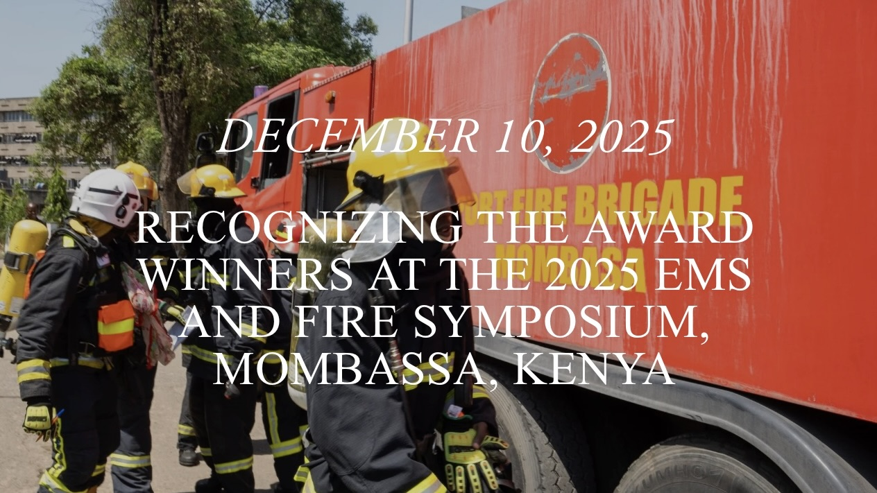
from africafiremission.org
Each year, the EMS and Fire Symposium in Kenya features a competition where first responders can practice the skills they sharpened in the classes and trainings. As noted by Fire Chief Wako Abgudo, competitions are a great way to foster growth and expand the skills of first responders by giving them experience that allows first responders to “think faster, work better as a team, improve their speed, fix mistakes, and build confidence.”
After the competition, AFM and other local groups present outstanding firefighters and EMTs awards to recognize their abilities. This year, in addition to awarding winners of the competition, AFM presented an inaugural award to recognize three outstanding fire prevention instructors. We would like to recognize the different award winners from this year’s symposium to highlight the ever-growing fire service in Africa and the determination of first responders in Kenya and beyond.
The John Kiama Fire Prevention Memorial Award
A core pillar of our mission is community risk reduction development. Through training firefighters and community leaders with materials like our fire prevention curriculum, individuals are empowered to train others and share fire prevention tips and skills. To recognize these fire prevention advocates who take their time to share fire prevention skills to others, AFM has instituted the annual John Kiama Fire Prevention Memorial Award. The award recognizes three fire prevention advocates who reached the most people through fire prevention outreach in local communities. This memorial award honors Fire Chief John Kiama, a pillar of fire safety in Kirinyaga County, Kenya who passed away this year (2025). In remembering Chief Kiama, these awards keep his spirit of safety at the forefront while recognizing up and coming leaders in the first responder community.
This year, Samuel Owino, Cyrus Kalemungorok, and Gedion Owiti received first, second, and third place respectively. These individuals are pillars of fire safety in their communities that keep those around them safe through valuable instruction. Collectively, the three award winners have reached over 65,000 people through fire prevention outreach! This number continues to grow as these advocates share their expertise with those around them. In total, the ten individuals that were considered for this award have reached over 94,000 people and counting. We hope this award inspires other first responders to continue their fire prevention outreach and empowers the award winners to reach even more people in 2026.
José Ngunjiri, AFM’s Fire Safety Officer, shared words of encouragement to this year’s award winners: “Congratulations to all the three winners! The more we are out here in our counties doing fire prevention, the more we reduce fires.” We are grateful for the difference these advocates make and encourage everyone to share their knowledge to make the world a safer place.

Fire Competition Winners
Competition was tight at this year’s Symposium! As counties continue to develop their first responder skills, these events serve as a way to develop healthy competition and foster determination. This year, 6 teams competed in the fire competition that the Chief Fire Officer’s Association - Kenya hosts with the Kenya Council of Emergency Medical Technicians. In overall performance, Makueni County took first place, with Nairobi and Nyeri as the runner-ups in second and third place.
World Class Training
Additionally, firefighters and EMTs took home certificates for their hard-work in there classes . This year, courses included tactical firefighting, leadership, water rescue, active bleeding control, basic life support, incident command systems, and more! We are grateful for the over 550 first responders who joined us this year and look forward to 2026 where growth and development will continue to flourish.

We are grateful for all the trainers and participants of this year’s Symposium! We look forward to the future of the fire service in Africa and are thrilled at the progress we see. To learn more about this year’s event and our other training trips, please watch the highlight video below and subscribe to our YouTube channel! Interested in supporting our mission? Consider making a donation or applying for a 2026 Mission Trip.
Watch a highlight from this year’s Symposium!

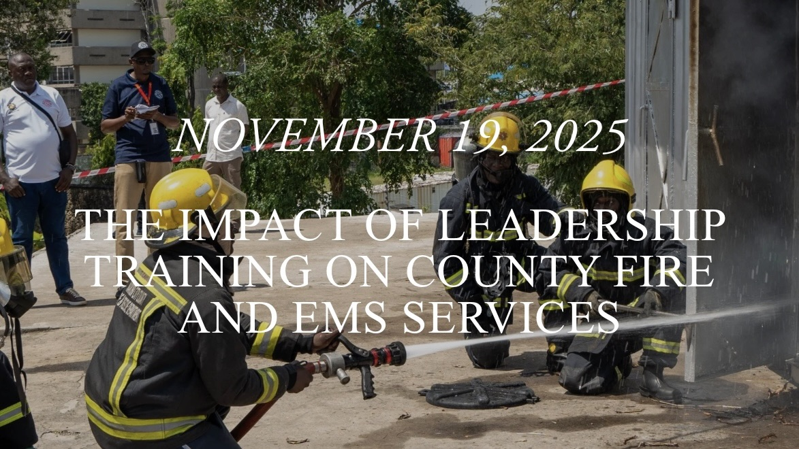
from africafiremission.org
by Suleiman Adan Issack, Chief Fire Officer – Mandera County Leadership Class Instructor
The 2025 Fire and EMS Symposium at Bandari Academy in Mombasa provided an excellent platform for counties across Kenya to strengthen their emergency response capacity. As an instructor in the leadership class, I witnessed the dedication of Kenya’s firefighters and paramedics first-hand and saw the critical need for strong, ethical, and modern leadership within the sector.
The symposium brought together fire officers, EMS personnel, trainers, and county delegates to exchange ideas, demonstrate best practices, and engage in practical drills. These interactions reaffirmed that leadership is the backbone of effective fire and EMS services. Key lessons focused on communication, decision-making, team coordination, and community engagement—skills essential for improving county readiness and service delivery.
Counties investing in leadership development can expect significant transformation. Trained leaders will enhance operational efficiency, strengthen safety culture, and promote accountability. Strong leaders will boost team morale, build trust, and improve collaboration across counties.
The impact of this training extends far beyond the event. As participants return to their counties, they carry new knowledge, confidence, and vision that will uplift emergency services and strengthen public safety across Kenya.
I had the opportunity to speak with some of first responders who attended the leadership class, who reflected on their valuable experiences at the Symposium. Ronald Simiyu Waswa, the Chief Fire Officer of Trans Nzoia County, shared that “the leadership class provided valuable insights into decision-making, team coordination, and crisis management. Applying these principles will improve governance, emergency response, and community trust in Trans Nzoia County.”
Teresiah Ambiah, a Paramedic for Nandi County, shared some key takeaways, including the value of the new perspectives, networking, and skill development offered in courses during the symposium. Along with gaining leadership and community building skills, Teresiah states that courses made them motivated to apply new ideas in their leadership role.

We are grateful for all the trainers and participants of this year’s Symposium! We look forward to the future of the fire service in Africa and are thrilled at the progress we see. To learn more about this year’s event and our other training trips, please watch the highlight video below and subscribe to our YouTube channel!

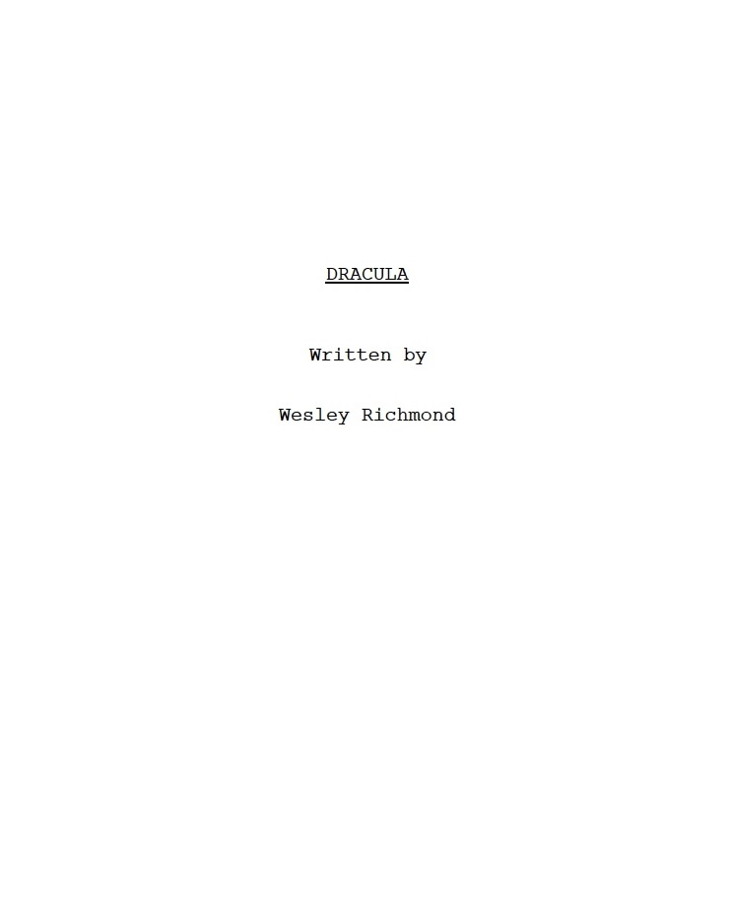

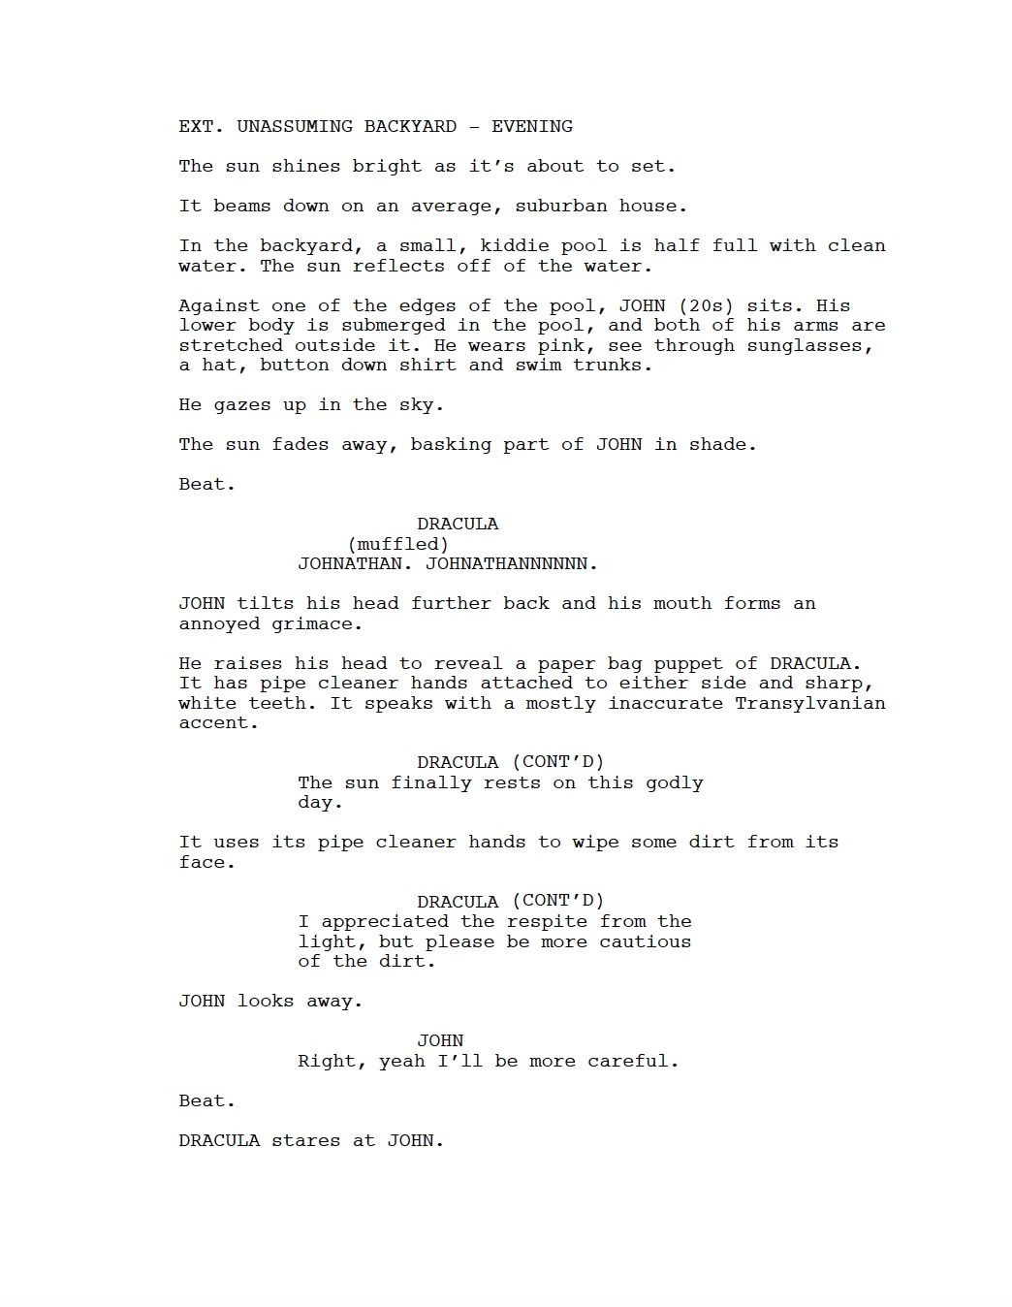

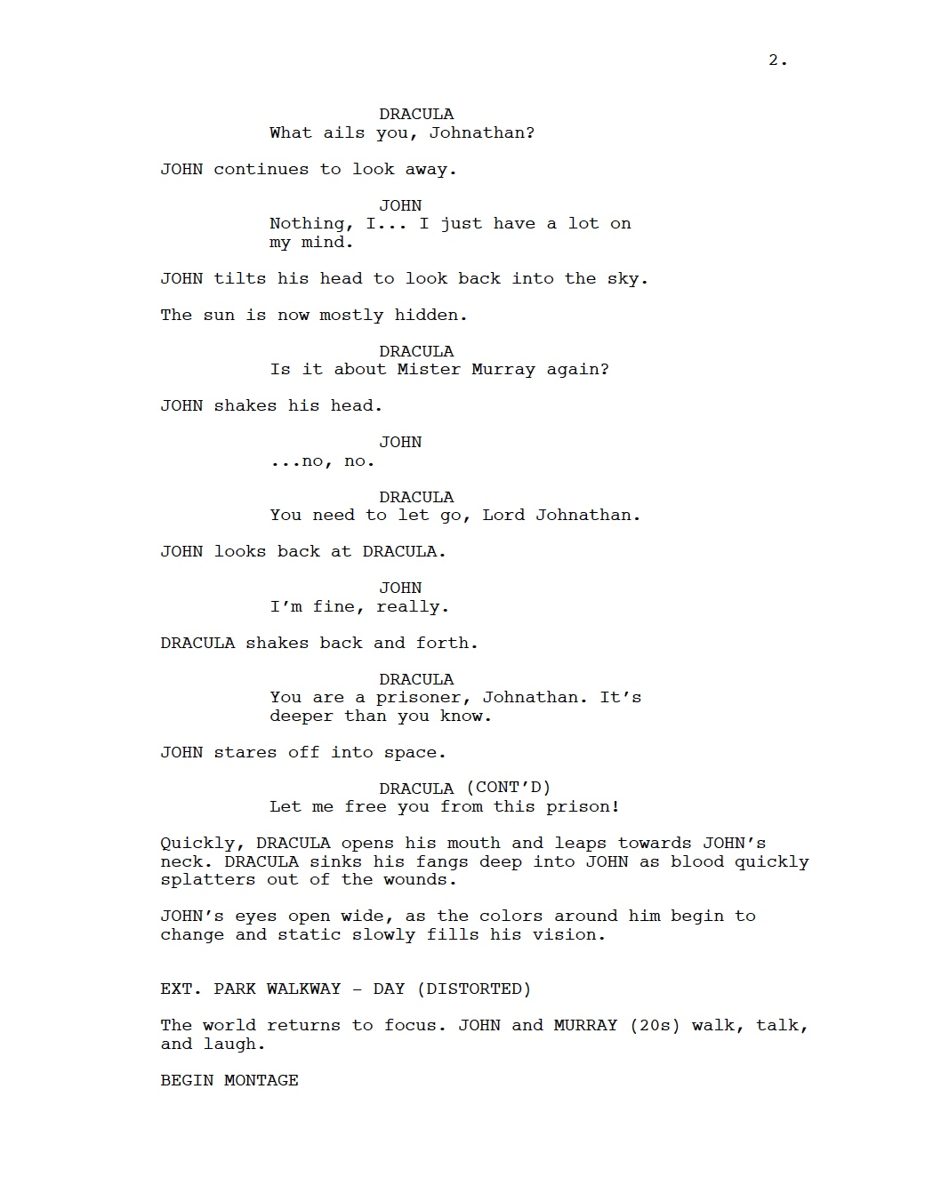

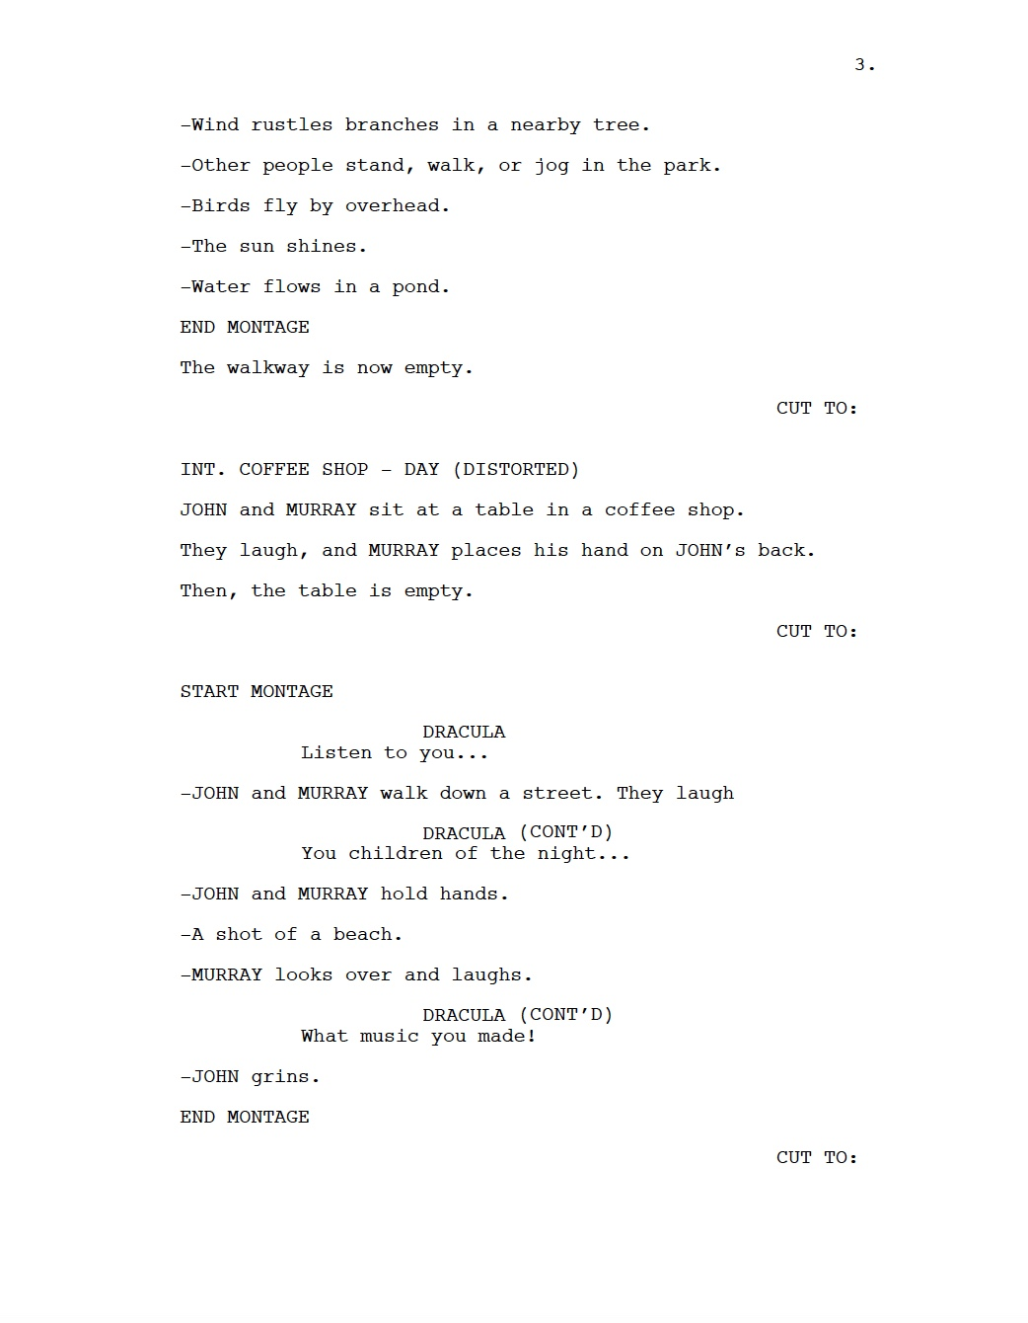

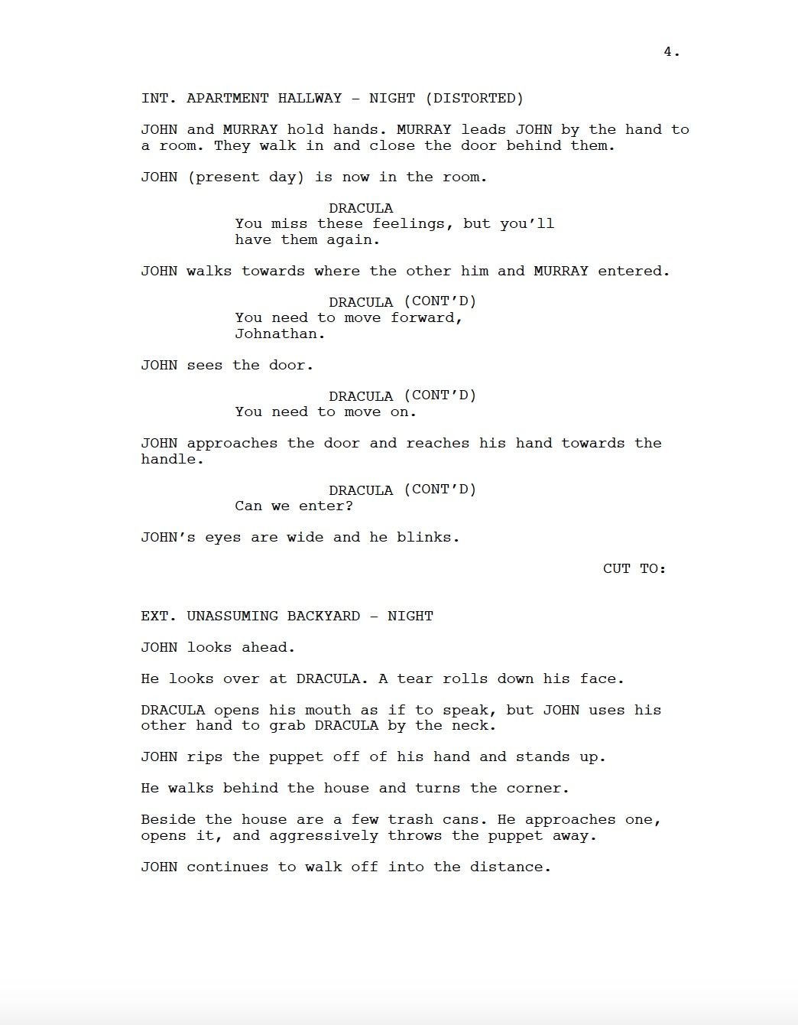
Dracula – A Short Film: Notes and Storyboards
Due to time and budget constraints, editor Reece Rexroad and I decided to change some scenes for the final project. As you watch the short film, some moments may be more abstract than how they were originally conceived in the screenplay. This was intentional and I hope it fosters more discussions and curiosity.
Dracula – A Short Film premiered on November 21st, 2025 at the Esquire Theatre and released online on December 12th, 2025.
Shots 1C and 1D Storyboards
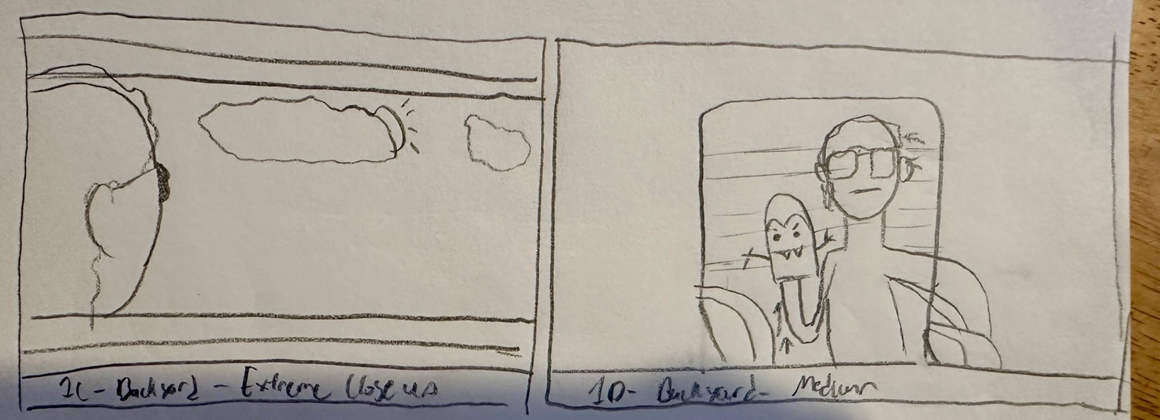
Shots 2(x) and 3A Storyboards
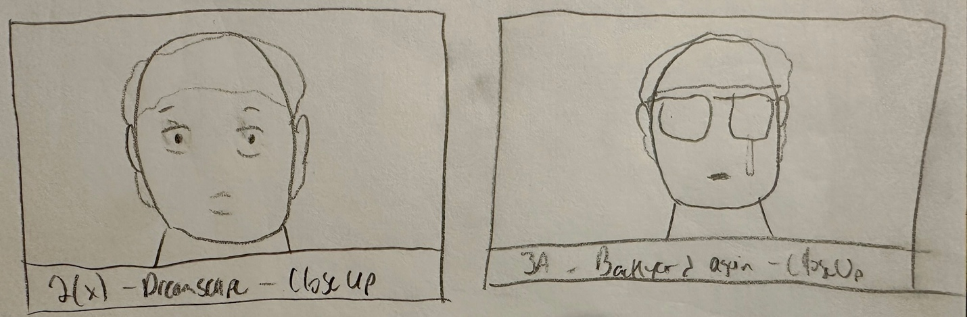

Horror Movie Versus Films
Recently, I watched Freddy vs. Jason. It wasn’t very good, but it was a charming watch that was at least entertaining. But as I watched Freddy fling Jason around like a pinball and Jason continuously get up to keep fighting, even after the most extreme of injuries, I couldn’t help but think about the ‘versus’ horror movie and how it’s really a fad of a bygone era.
The early 2000s saw a few high-profile horror crossovers, where legendary movie monsters did battle on the big screen. Take the previously mentioned Freddy vs. Jason or the Alien vs. Predator duology. While the quality of these films may be… low, they each handily made back their budget and multiple times more at the box office. But since then, when it comes to crossing over mainstream, Hollywood movie monsters, there’s been nothing. But how, in today’s age of endless sequels, remakes, and crossovers, have we not seen more of these? And will we see anymore? Before we answer that, let’s go over a history of these monumental crossovers and see what that may reveal.
The Origins
Arguably, the first of these “versus” crossover monster movies was Universal’s 1943 film Frankenstein meets Wolf Man. This film came after roughly two decades of Universal’s iconic monster movies, but in the late 30s and 40s, the studio began to experiment with taking these characters and ideas in new directions. To make sequels, they would usually go the route of gender-swapping the monster or focusing on the character’s child or a new environment for them to haunt. Frankenstein was successful? Well, they made Bride of Frankenstein. The Invisible Man did well? We got The Invisible Woman! Werewolf in London is popular? Now he’s The Wolf Man and he’s in Wales.
All of these to say, after tons of these films, the creatives were looking for a new way to continue making films with these characters. After deliberation on which characters to crossover and how to pull it off, it was decided that Frankenstein’s monster would meet (and fight) each other. Surprisingly (and maybe unsurprising in some ways), the film was a middling release critically and commercially. Thus, while there were two more “monster rally” or crossover films after this, this mostly ended the monster fights between the Universal classics.
About a decade later, the tokusatsu classic Godzilla released and quickly garnered international fame. As Japan’s cinematic reach grew, it was clear that Godzilla was a franchise ripe for sequels. Inherent to Godzilla as a character is large scale. With this in mind, it’s unsurprising that less than ten year’s after the first film’s release, Godzilla clashed with another giant monster in 1962’s King Kong vs. Godzilla. This film quickly became an international sensation, with Universal acquiring the rights and releasing the film in other markets (including the US). From there, Godzilla would become the focal point of numerous Kaiju crossovers, with many of the monsters coming from the Godzilla mythos. After a boom in the 60s and 70s, these crossover films died down and wouldn’t reach international success again until Legendary Pictures’ Monsterverse began releasing crossovers in the late 2010s to today.
What Went Wrong?
Maybe the root cause for a lot of this is the simple fact that these movies can be hard to pull off for little-to-no critical success. Freddy vs. Jason is perhaps the best example of this. While it has a cult following today and did well enough in the box office, it was in development hell for nearly twenty years, only to release to middling reviews. Interestingly, many of these films are financially successful, however in the grand scheme of things, these crossovers have never made their way back to the big screen.
Largely, these crossovers have been relegated to comic books (like Freddy vs. Jason vs. Ash and Marvel Zombies vs. The Army of Darkness) and video games (like Mortal Kombat X‘s iconic horror icon DLC). These products and smaller scale pieces of media are also generally financially successful and almost certainly take less money up front and less logistical agreements between the different rights holders.
So, with this in mind, will we ever get back to frequent monster fighting madness? In my opinion, yes! As mentioned before, this decade has actually seen the release of new Godzilla crossovers, and there have been frequent talks of a new big screen crossover between Alien and Predator (this is all but confirmed in promotional material for the upcoming Predator: Badlands, as Alien franchise technology and iconography are seen). Jason Vorhees, whose troubling rights agreements had made him a real hassle to try to crossover with, finally entered into a new era and has already appeared in this year’s Fortnite Halloween event.
It’s interesting to consider how this cycle of monster movies has fluctuated in and out of mainstream consciousness. But, perhaps soon we will be seeing frequent releases in this niche subgenre, if only for a while. And in the meantime, this week would be a great time to throw one of these on.
Happy Halloween!

Notes on Inclusions and Formatting
p. 10: The first two inclusions are from a class I took in Spring 2025. This works cited page covers the sources cited in those essays.
pp. 11-25: This is my inclusion from The Cincinnatus Papers, an undergraduate research journal project created by students at the University of Cincinnati. My paper was available in the online journal and is now available to read in full here! It was edited by Luc Balson and Serene Tarabishi.
pp. 26-37: Edited by Rich Richmond with notes from Megan Boyd.
p. 29: “verist tyro,” meaning a beginner or novice. Cited from Talking Pictures: How They Are Made, and How to Appreciate Them that featured a different spelling than its common writing, “veriest tyro.”
pp. 41-42: Original article written by Chief Fire Officer Suleiman Adan Issack. Features edits, formatting, and additional copy from me.
pp. 43-47: Dracula – A Short Film screenplay originally written in Final Draft 13.
p. 48: Notes and storyboards gathered from documents before and during the production. These are gathered to give additional context to the screenplay. Watch the short film here.
pp. 49-51: Full, formatted post and other similar works available on wesleyrichmond.com.

All featured writings were made by humans.



